JAVA Assignment 2
Q1. Electricity Bill Calculator Create a Java program to calculate a household electricity bill. Requirements
● Accept customer name, consumer number, and units consumed.
● Calculate bill using slab rates such as:
○ First 100 units → Rs. 5 per unit
○ Next 100 units → Rs. 7 per unit
○ Above 200 units → Rs. 10 per unit
● If the bill exceeds Rs. 1500, apply a 5% surcharge.
● Display complete bill details.
import java.util.Scanner;
class ElectricityBill
{
public static void main(String args[])
{
Scanner sc = new Scanner(System.in);
System.out.print("Enter the Customer Name : ");
String name = sc.nextLine();
System.out.print("Enter the Customer Number : ");
int num = sc.nextInt();
System.out.print("Enter the Units Consumed : ");
float units = sc.nextFloat();
double bill = 0;
if(units <= 100)
{
bill = units * 5;
}else if(units <= 200)
{
bill = (100 * 5) + (units - 100) * 7;
}else if(units > 200)
{
bill = (100 * 5) + (100 * 7) + (units - 200) * 10;
}
double finalbill;
if(bill > 1500)
{
finalbill = bill + (0.05 * bill);
}else{
finalbill = bill;
}
System.out.println("Customer Name :" + name);
System.out.println("Customer Number :" + num);
System.out.println("Units Consumed :" + units);
System.out.println("Electricity Bill :" + finalbill);
}
}
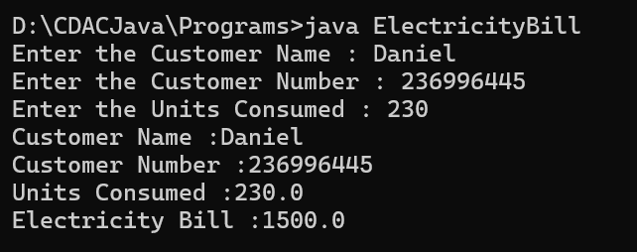
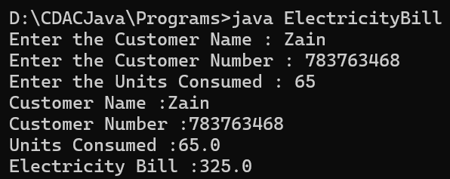
Q2. Student Result Processing System
Create a program for a school to manage a student’s marks.
Requirements
● Accept student name, roll number, and marks in 5 subjects.
● Calculate total, average, percentage.
● Display grade using conditions:
○ 90 and above → A
○ 75 to 89 → B
○ 60 to 74 → C
○ 40 to 59 → D
○ Below 40 → Fail
● Show whether the student is promoted or not.
import java.util.Scanner;
public class SchoolManagement
{
public static void main(String args[])
{
Scanner sc = new Scanner (System.in);
System.out.print("Enter the Student name : ");
String sname = sc.nextLine();
System.out.print("Enter the Roll number : ");
int roll = sc.nextInt();
int[] marks = new int[5];
int total = 0;
int avg = 0;
System.out.println("Enter marks of 5 subjects:");
for (int i = 0; i < 5; i++)
{
marks[i] = sc.nextInt();
total = total + marks[i];
avg = total / 5;
}
System.out.println("Total Marks : " + total);
System.out.println("Average : " + avg);
double per = (double) total / 500 * 100;
System.out.println("Percentage: " + per + "%");
if (per >= 90)
{
System.out.println("Grade : A");
System.out.println("Student is promoted.");
}else if(per >= 75)
{
System.out.println("Grade : B");
System.out.println("Student is promoted.");
}else if(per >= 60)
{
System.out.println("Grade : C");
System.out.println("Student is promoted.");
}else if(per >= 40)
{
System.out.println("Grade : D");
System.out.println("Student is promoted.");
}else
{
System.out.println(" FAIL ");
System.out.println("Student is Not promoted.");
}
}
}
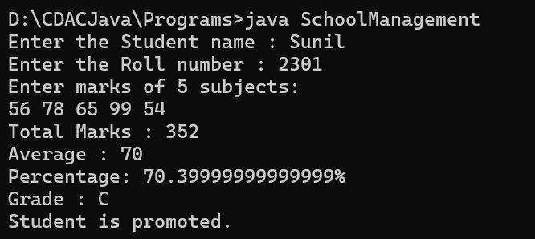

Q3. ATM Simulation Create a simple ATM system.
Requirements
● Show a menu using switch-case:
1. Check Balance
2. Deposit Money
3. Withdraw Money
4. Exit
● Start with an initial balance.
● Prevent withdrawal if balance is insufficient.
● Continue showing the menu until the user chooses Exit
import java.util.Scanner;
public class ATMSystem
{
public static void main(String args[])
{
Scanner sc = new Scanner(System.in);
double balance = 500.0;
int choice;
do {
System.out.println("\n--- ATM Menu ---");
System.out.println("1. Check Balance");
System.out.println("2. Deposit Money");
System.out.println("3. Withdraw Money");
System.out.println("4. Exit");
System.out.print("Enter your choice: ");
choice = sc.nextInt();
switch (choice)
{
case 1 :
{
System.out.println("Balance :" + balance);
break;
}
case 2 :
{
System.out.println("Enter the amount to deposit : ");
double deposit = sc.nextDouble();
balance = balance + deposit;
System.out.println("Deposited successfully. New balance: " + balance);
break;
}
case 3 :
{
System.out.println("Enter the amount to Withdraw : ");
double withdraw = sc.nextDouble();
if (withdraw <= balance)
{
balance = balance - withdraw;
System.out.println("Withdrawal successful. New balance: " + balance);
} else {
System.out.println("Insufficient Balance.");
}
break;
}
case 4 :
{
System.out.println("Thank you for using ATM. GoodBye!");
break;
}
default :
System.out.println("Invalid choice. Please try again later.");
}
} while (choice != 4);
}
}
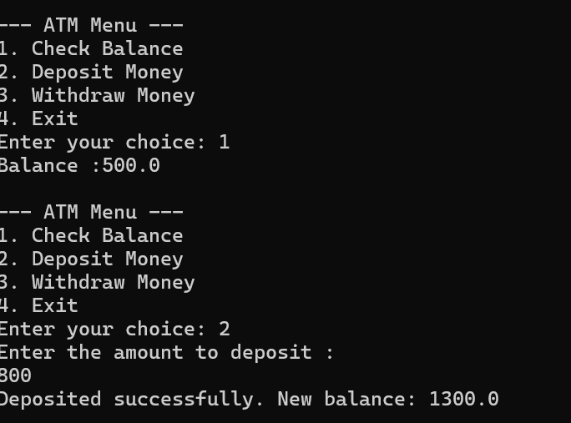
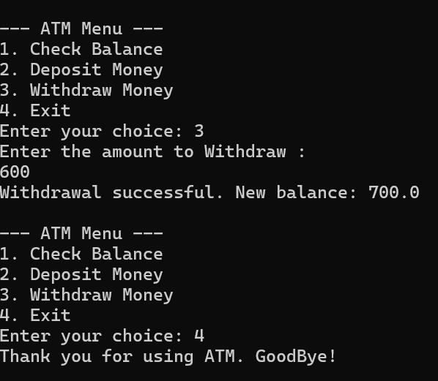

Q4. Grocery Store Bill Generator Create a billing system for a small grocery shop. Requirements
● Accept item names, quantity, and price for multiple items.
● Store item totals in arrays.
● Calculate total bill amount.
● Apply discount:
○ 10% discount if bill is above Rs. 3000
● Print the final bill in proper format.
import java.util.Scanner;
public class GroceryBillGenerator
{
public static void main(String args[])
{
Scanner sc = new Scanner(System.in);
String[] itemNames = new String[10];
int[] quantities = new int[10];
double[] prices = new double[10];
double[] totals = new double[10];
int itemCount = 0;
double total = 0;
System.out.print("Enter the number of items : ");
itemCount = sc.nextInt(); //counter for number of items
sc.nextLine();
for (int i = 0; i < itemCount; i++)
{
System.out.println("Enter the Details for items" + (i + 1));
System.out.print("Item Name: "); // item names
itemNames[i] = sc.nextLine();
System.out.print("Quantities: ");
quantities[i] = sc.nextInt(); //quantity of items
System.out.print("Price per unit: ");
prices[i] = sc.nextDouble(); //prices per item
sc.nextLine();
totals[i] = quantities[i] * prices[i];
total = total + totals[i]; //Total bill per customer
}
double discount = 0;
if (total > 3000)
{
discount = total * 0.1 ; // Discount Calculation
}
double finalAmount = total - discount;
// Final bill
System.out.println("\n ============== Final Bill ============= ");
System.out.println("Item"+"\tQuantity"+"\tPrice"+"\tTotal");
System.out.println("----------------------------------------------");
for (int i = 0; i <= itemCount; i++)
{
System.out.println(itemNames[i] + "\t" + quantities[i] + "\t" + prices[i] + "\t" + totals[i]);
}
System.out.println("-------------------------------");
System.out.println("Grand Total: "+ total);
System.out.println("Discount: " + discount);
System.out.println("Final Amount: "+ finalAmount);
}
}
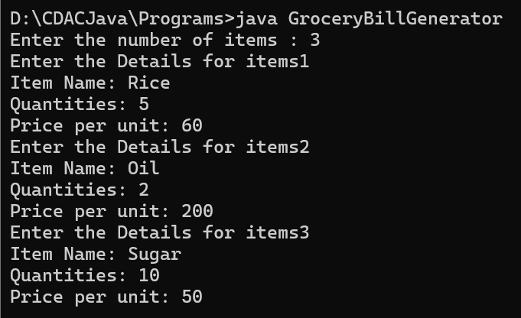
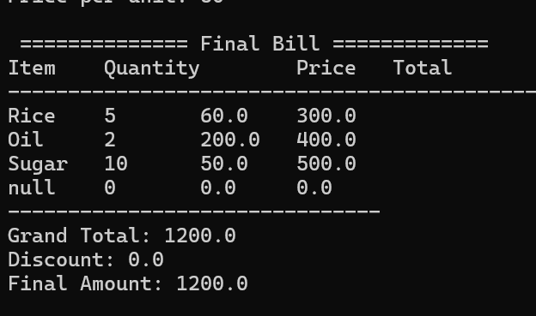

Q. 5. Employee Salary Slip Generator
Create a Java program to generate salary slips for employees.
Requirements
● Accept employee name, ID, basic salary.
● Calculate:
○ HRA = 20% of basic salary
○ DA = 10% of basic salary
○ PF = 8% of basic salary
● Calculate net salary.
● Display a formatted salary slip.
import java.util.Scanner;
class EmployeeSalarySlip
{
public static void main(String args[])
{
Scanner sc = new Scanner(System.in);
System.out.print("Enter the Employee name: ");
String ename = sc.nextLine();
System.out.print("Enter the Employee ID: ");
int empId = sc.nextInt();
System.out.print("Enter the Basic Salary: ");
double salary = sc.nextDouble();
double hra = salary * 0.2;
double da = salary * 0.1;
double pf = salary * 0.08;
double netSalary = salary + hra + da - pf;
System.out.println("--------------------------------");
System.out.println(" SALARY SLIP ");
System.out.println("--------------------------------");
System.out.println("Employee Name : " + ename);
System.out.println("Employee ID : " + empId);
System.out.println("Basic Salary : " + salary);
System.out.println("HRA (20%) : " + hra);
System.out.println("DA (10%) : " + da);
System.out.println("PF (8%) : " + pf);
System.out.println("--------------------------------");
System.out.println("Net Salary : " + netSalary);
System.out.println("--------------------------------");
}
}
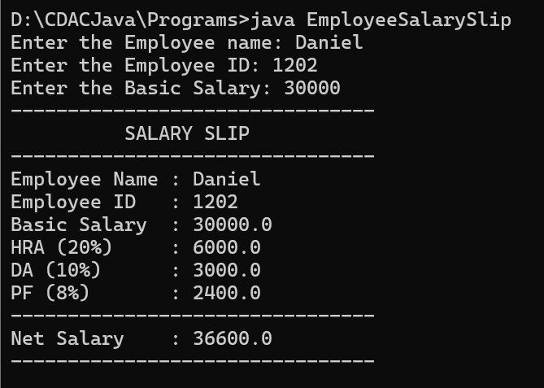

Q6. Bus Ticket Booking System
Create a program for booking bus seats.
Requirements
● Assume a bus has 10 seats.
● Use an array to mark seats as booked or available.
● Show a menu:
1. View Available Seats
2. Book a Seat
3. Cancel a Seat
4. Exit
● Do not allow double booking.
import java.util.Scanner;
class BusBooking
{
public static void main(String args[])
{
Scanner sc = new Scanner(System.in);
// Array to represent 10 seats (false = available, true = booked)
boolean [] seats = new boolean[10];
int choice;
do {
System.out.println("\n----- Bus Ticket Bookings -----");
System.out.println("1. View Available Seats");
System.out.println("2. Book a Seat");
System.out.println("3. Cancel a Seat");
System.out.println("4. Exit.");
System.out.print("Enter your choice : ");
choice = sc.nextInt();
switch(choice)
{
case 1:
System.out.println("\nAvailable Seats");
for (int i = 0; i < seats.length; i++)
{
if(!seats[i]){
System.out.println("Seat " + (i + 1) + " is available");
}
}
break;

case 2:
System.out.print("Enter the seat number to book (1-10) : ");
int seatnum = sc.nextInt();
if(seatnum < 1 || seatnum > 10){
System.out.println("Seats not available.");
}else if (seats[seatnum - 1]){
System.out.println("Seat already booked!");
}else{
seats[seatnum - 1] = true;
System.out.println("Seat booked Successfully.");
}

case 3:
System.out.print("Enter the seat number to cancel (1-10) : ");
int cancelSeat = sc.nextInt();
if (cancelSeat < 1 || cancelSeat > 10){
System.out.println("Invalid seat number.");
}else if(!seats[cancelSeat - 1]){
System.out.println("Seat is not booked yet!");
}else{
seats[cancelSeat - 1] = false;
System.out.println("Booking for seat number " + cancelSeat + " is Cancelled.");
}
break;
case 4:
System.out.println("Thank you for using the Bus Booking System. Goodbye!");
break;
default :
System.out.println("Invalid choice. Please try again.");
}
}while (choice != 4);
}
}
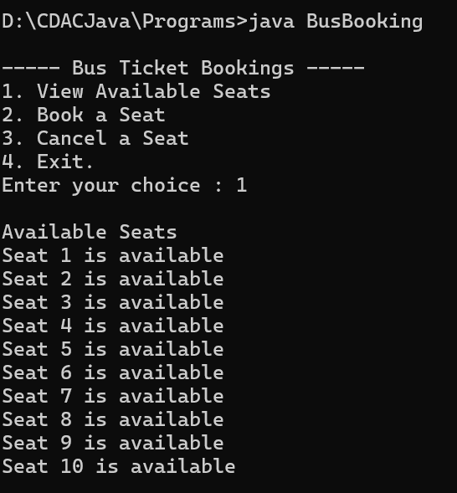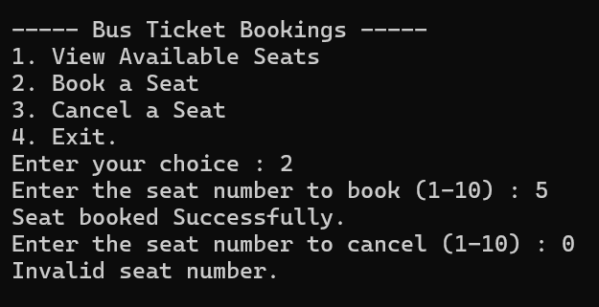
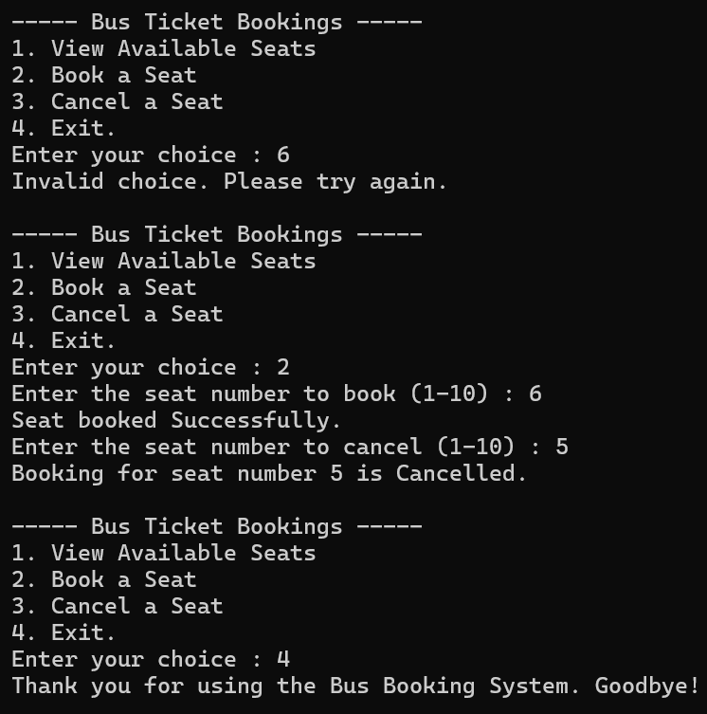

Q7. Mobile Recharge System
Create a recharge application for prepaid mobile users.
Requirements
● Ask for mobile number and recharge amount.
● Show recharge plans using switch-case.
● Example:
○ Rs. 199 → 28 days validity
○ Rs. 399 → 56 days validity
○ Rs. 599 → 84 days validity
● Print recharge confirmation with plan details.
import java.util.Scanner;
class MobileRechargeSystem
{
public static void main(String args[])
{
Scanner sc = new Scanner (System.in);
// Ask for mobile number
System.out.print("Enter your mobile number: ");
String mobnum = sc.nextLine();
// Ask for recharge amount
System.out.print("Enter the amount of recharge: ");
int amt = sc.nextInt();
String planDetails;
switch (amt)
{
case 199:
planDetails = "Recharge of Rs. 199 -> Validity: 28 days";
break;
case 399:
planDetails = "Recharge of Rs. 399 -> Validity: 56 days";
break;
case 599:
planDetails = "Recharge of Rs. 599 -> Validity: 84 days";
break;
default:
planDetails = "Invalid recharge amount. Please choose Rs. 199, Rs. 399, Rs. 599.";
}
System.out.println("\nRecharge Confirmation:");
System.out.println("Mobile Number: " + mobnum);
System.out.println("Amount: Rs. " + amt);
System.out.println("Plan Details: " + planDetails);
}
}
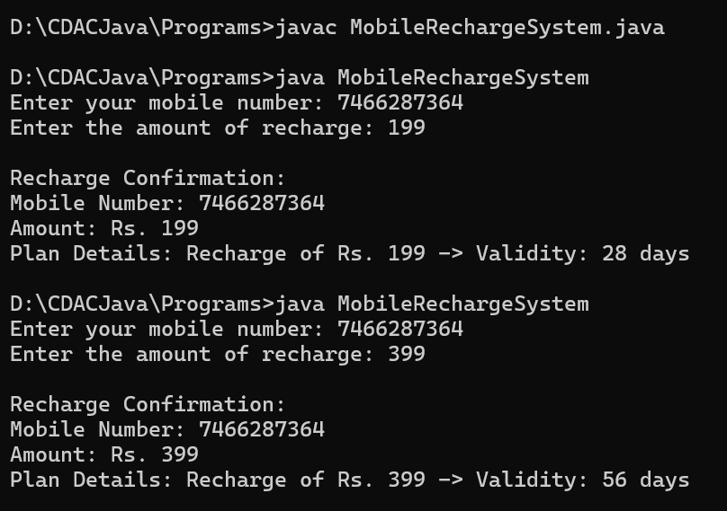
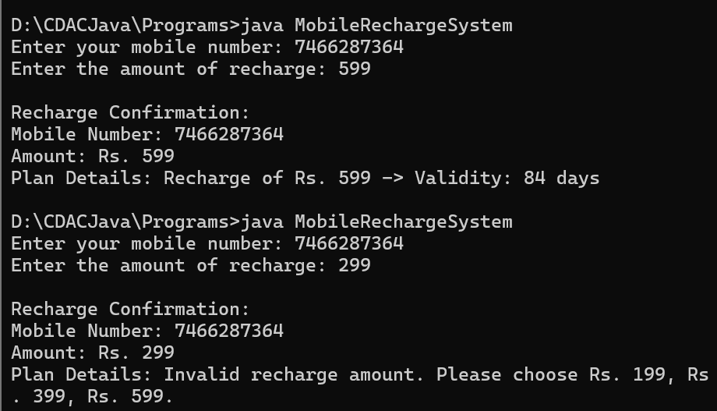

Q8. Hospital Patient Record System
Create a simple patient management program.
Requirements
● Create a class Patient with:
○ patient ID
○ patient name
○ age
○ disease
● Create objects for at least 3 patients.
● Display patient details.
● Add a method to check whether the patient is a senior citizen (age 60 or above).
class Patient {
int patientId;
String pName;
int age;
String disease;
// Constructor
Patient(int patientId, String pName, int age, String disease) {
this.patientId = patientId;
this.pName = pName;
this.age = age;
this.disease = disease;
}
// Method to display patient details
void display() {
System.out.println("Patient ID: " + patientId);
System.out.println("Name: " + pName);
System.out.println("Age: " + age);
System.out.println("Disease: " + disease);
System.out.println("Senior Citizen: " + (isSenior() ? "Yes" : "No"));
System.out.println("-----------------------------------");
}
//Method to check senior citizen
boolean isSenior()
{
return age >= 60;
}
}
class HospitalPatientRecordSystem
{
public static void main(String args[])
{
Patient p1 = new Patient(101, "Ramesh Kumar", 56, "Diabetes"); //object creation
Patient p2 = new Patient(102, "Sita Devi", 80, "Arthritis");
Patient p3 = new Patient(103, "Amit Mishra", 23, "Hypertension");
//Display patient details
p1.display();
p2.display();
p3.display();
}
}
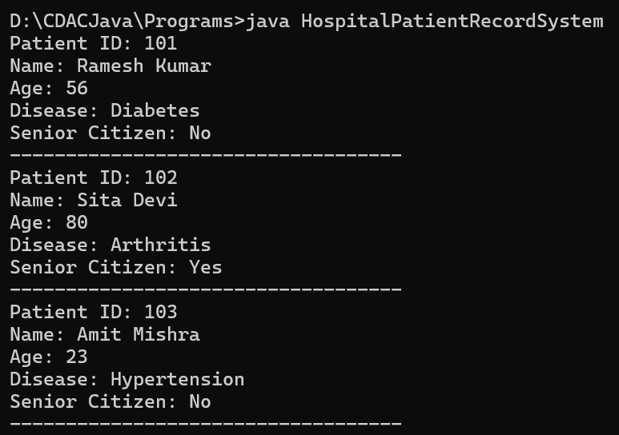
Q9. Daily Expense Tracker
Create a program to track a person’s daily expenses.
Requirements
● Accept expenses for 7 days in an array.
● Calculate:
○ total weekly expense
○ average expense
○ highest expense
○ lowest expense
● Display the day on which the highest expense occurred.
import java.util.Scanner;
public class ExpensesTracker {
public static void main(String[] args) {
Scanner sc = new Scanner(System.in);

// Accept expenses for 7 days
double[] expenses = new double[7];
String[] days = {"Day 1", "Day 2", "Day 3", "Day 4", "Day 5", "Day 6", "Day 7"};

for (int i = 0; i < 7; i++) {
System.out.print("Enter expense for " + days[i] + ": ");
expenses[i] = sc.nextDouble();
}

// Calculate total, average, highest, lowest
double total = 0;
double highest = expenses[0];
double lowest = expenses[0];
int highestDayIndex = 0;

for (int i = 0; i < 7; i++) {
total += expenses[i];
if (expenses[i] > highest) {
highest = expenses[i];
highestDayIndex = i;
}
if (expenses[i] < lowest) {
lowest = expenses[i];
}
}
double average = total / 7;
// Display results
System.out.println("\n--- Weekly Expense Report ---");
System.out.println("Total Weekly Expense: Rs. " + total);
System.out.println("Average Daily Expense: Rs. " + average);
System.out.println("Highest Expense: Rs. " + highest + " on " + days[highestDayIndex]);
System.out.println("Lowest Expense: Rs. " + lowest);
}
}
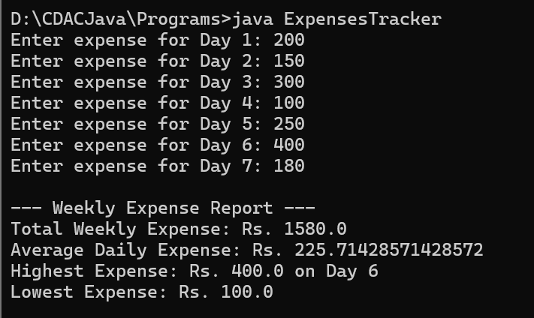
Q10. Restaurant Order Management System
Create a program for restaurant management.
Requirements
● Display a food menu with price list.
● Let the user order multiple items.
● Use loop and switch-case for repeated ordering.
● Calculate total amount.
● Add GST of 5%.
● Print final bill.
import java.util.Scanner;
class Restaurant {
double totalAmt;
// Constructor
Restaurant() {
totalAmt = 0;
}
// display menu
void displayMenu() {
System.out.println("\n--- Food Menu ---");
System.out.println("1. Pizza - Rs. 250");
System.out.println("2. Burger - Rs. 150");
System.out.println("3. Pasta - Rs. 200");
System.out.println("4. Coffee - Rs. 100");
System.out.println("5. Exit & Generate Bill");
}

// Method to process order using switch-case
void orderItem(int choice) {
switch (choice) {
case 1:
totalAmt += 250;
System.out.println("Pizza added!");
break;
case 2:
totalAmt += 150;
System.out.println("Burger added!");
break;
case 3:
totalAmt += 200;
System.out.println("Pasta added!");
break;
case 4:
totalAmt += 100;
System.out.println("Coffee added!");
break;
case 5:
// Exit handled in main loop
break;
default:
System.out.println("Invalid choice. Please try again.");
}
}
// print final bill
void printBill() {
double gst = totalAmt * 0.05; // 5% GST
double finalAmt = totalAmt + gst;
System.out.println("\n--- Final Bill ---");
System.out.println("Total Amount (before GST): Rs. " + totalAmt);
System.out.println("GST (5%): Rs. " + gst);
System.out.println("Final Amount to Pay: Rs. " + finalAmt);
}
}
public class RestaurantOrderManagementSystem {
public static void main(String[] args) {
Scanner sc = new Scanner(System.in);
Restaurant restaurant = new Restaurant();

int choice;
do {
restaurant.displayMenu();
System.out.print("Enter your choice: ");
choice = sc.nextInt();
restaurant.orderItem(choice);
} while (choice != 5);
restaurant.printBill();
}
}
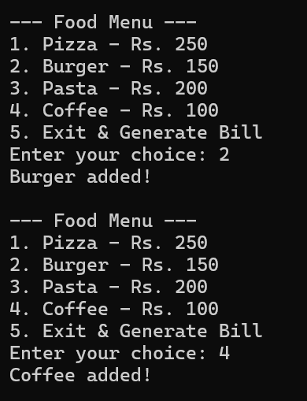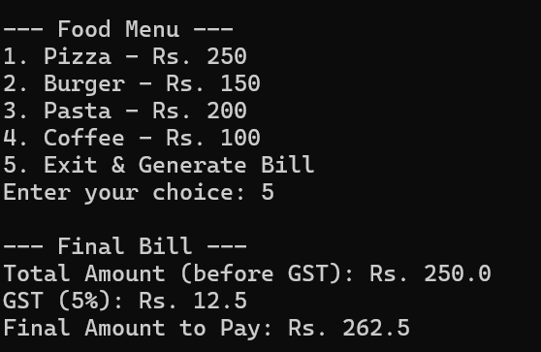
Q 11. Calculator System (Overloaded Methods)
Create a Java program for a calculator:
Requirements:
● Create methods named calculate
● Overload them for:
○ int + int
○ double + double
○ int + int + int
● Call all methods from main
● Display results clearly
import java.util.Scanner;
class Calculator
{
int a = 0;
int b = 0;
int c = 0;
double x = 0.0;
double y = 0.0;
void calculate(int a, int b)
{
int res = a + b;
System.out.println("int + int = " + res);
}
void calculate(double x, double y)
{
double res = x + y;
System.out.println("double + double = " + res);
}
void calculate(int a, int b, int c)
{
int res = a + b + c;
System.out.println("int + int + int = " + res);
}
}
class CalculatorSystem
{
public static void main(String args[])
{
Calculator cal = new Calculator();
cal.calculate(10, 20);
cal.calculate(3.14, 8.7);
cal.calculate(20, 15, 3);
}
}
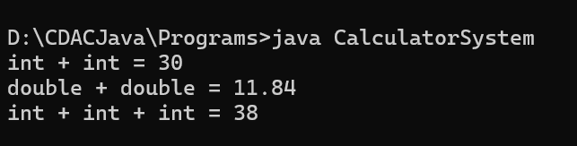

Q 12. Student Counter System
Create a class Student:
Requirements:
● Instance variables: name, rollNo
● Static variable: totalStudents
● Increment totalStudents every time object is created
● Display total number of students
Bonus: Add a static method to display count
import java.util.Scanner;
class Student
{
// instance variables
String name;
int rollNo;
static int totalStudents = 0; //static variable

Student(String name, int rollNo)
{
this.name = name;
this.rollNo = rollNo;
totalStudents++;
}
void display()
{
System.out.println("Name: " + name + " RollNO: " + rollNo);
}
static void displaytotalStudents()
{
System.out.println("Total Number of Students: " + totalStudents);
}
}

public class StudentCounterSystem
{
public static void main(String args[])
{
Student s1 = new Student("Aman", 101);
Student s2 = new Student("Saniya", 117);
Student s3 = new Student("Krish", 114);
s1.display();
s2.display();
s3.display();
Student.displaytotalStudents();
}
}
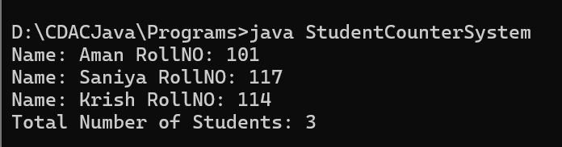

Q 13. Bank Account System
Create a class BankAccount:
Requirements:
● Variables: accountNumber, name, balance
● Use:
○ Default constructor
○ Parameterized constructor
● Display account details
● Create multiple objects using different constructors
import java.util.Scanner;
class BankAccount
{
int accountNumber;
String name;
double balance;

//default constructor
BankAccount()
{
accountNumber = 0;
name = "Unknown";
balance = 0.0;
}

//parameterized constructor
BankAccount( int accountNumber, String name, double balance)
{
this.accountNumber = accountNumber;
this.name = name;
this.balance = balance;
}

//print account details
void display()
{
System.out.println("------Account Details------");
System.out.println("Account Number: " + accountNumber);
System.out.println("Name: " + name);
System.out.println("Balance: " + balance);
}
}
public class BankAccountSystem
{
public static void main(String args[])
{
BankAccount bk1 = new BankAccount();
BankAccount bk2 = new BankAccount(101, "Ashish Kumar", 5000);
BankAccount bk3 = new BankAccount(102, "Nitu Singh", 10000);
bk1.display();
bk2.display();
bk3.display();
}
}
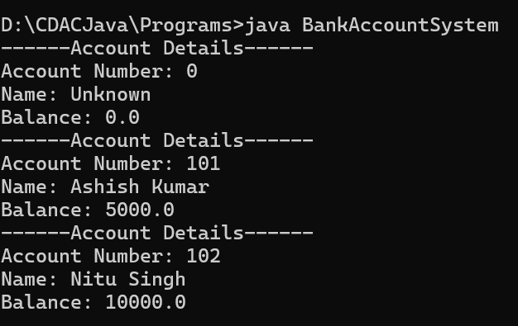

Q. 14. Salary Conversion System
Create a program:
Requirements:
● Take the salary as double
● Convert it into:
○ int (explicit casting)
○ float (implicit casting)
● Show the precision loss clearly
import java.util.Scanner;
class SalaryConversion
{
double salary;
SalaryConversion(double salary)
{
this.salary = salary;
}
int convertToInt()
{
return (int) salary;
}
float convertToFloat()
{
return (float) salary;
}
void displayConversions()
{
System.out.println("Original Salary (double): " + salary);
System.out.println("Converted to int (explicit): " + convertToInt());
System.out.println("Converted to float (implicit): " + convertToFloat());

}
}
public class SalaryConversionSystem
{
public static void main(String args[])
{
Scanner sc = new Scanner (System.in);
System.out.print("Enter your Salary (double): ");
double inputSalary = sc.nextDouble();
SalaryConversion salc = new SalaryConversion(inputSalary);
salc.displayConversions();
}
}
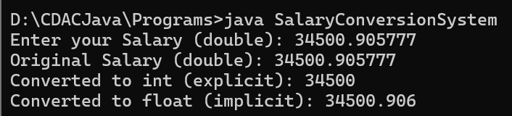

Q 15. Student Marks Table
Create a program:
Requirements:
● Store marks of 3 students in 3 subjects using 2D array
● Calculate:
○ Total per student
○ Average marks
● Display in table format
import java.util.Scanner;
class StudentMarks
{
public static void main(String args[])
{
int[][] marks = { {85, 90, 78},{70, 88, 92},{95, 80, 85} };
System.out.println("Student Sub1\tSub2\tSub3\tTotal \tAverage");
for (int i = 0; i < marks.length; i++)
{
int total = 0;
for (int j = 0; j < marks[i].length; j++)
{
total += marks[i][j];
}
double average = (double) total / marks[i].length;
System.out.print("S" + (i+1) + " \t ");
for (int j = 0; j < marks[i].length; j++)
{
System.out.print(marks[i][j] + " \t ");
}
System.out.println(total + " \t" + average);
}
}
}
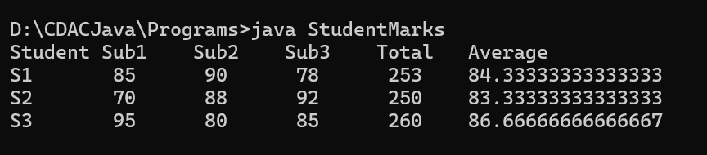

Q 16. Weekly Work Hours
Create a program:
Requirements:
● Each employee works different number of days
● Use jagged array to store hours
● Display all employee work hours
class WeeklyWorkHours
{
public static void main(String args[])
{
int[][] workHours = { {8, 7, 6}, {9, 8, 7, 6, 5}, {10, 9}, {6, 7, 8, 9} };
System.out.println("---Weekly Working Hours---");
for (int i = 0; i < workHours.length; i++)
{
System.out.print("Employee " + (i+1) + ": ");
for (int j = 0; j < workHours[i].length; j++)
{
System.out.print(workHours[i][j] + " ");
}
System.out.println();
}
}
}
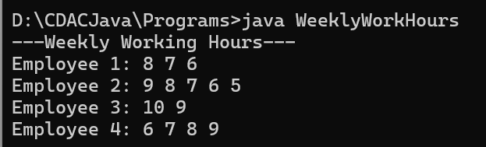

Q17. Scope Demonstration Program
Create a program:
Requirements:
● Declare variable inside:
○ Method
○ Loop
○ Block
● Try accessing outside scope (show error via comments)
● Print valid usages
public class ScopeDemoProgram
{
public static void main(String[] args)
{
// Variable inside method
int methodVar = 10;
System.out.println("Method variable: " + methodVar);
// Variable inside loop
for (int i = 0; i < 3; i++)
{
int loopVar = i * 2;
System.out.println("Loop variable (iteration " + i + "): " + loopVar);
}
// System.out.println(loopVar); // ERROR: loopVar not accessible outside loop
// Variable inside block
if (true)
{
int blockVar = 50;
System.out.println("Block variable: " + blockVar);
}
// System.out.println(blockVar); // ERROR: blockVar not accessible outside block
}
// System.out.println(methodVar); // ERROR: methodVar not accessible outside main method
}
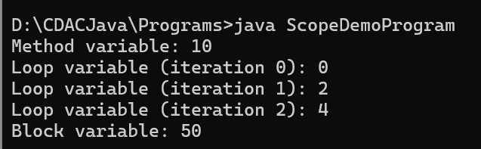

Q18. Expression Evaluator
Create a program:
Requirements:
● Take 3 numbers
● Perform:
○ (a + b) * c
○ a > b && b > c
○ a % b
● Show results with explanation
import java.util.Scanner;
class ExpressionEvaluator {
public static void main(String[] args) {
Scanner sc = new Scanner(System.in);
// Take 3 numbers
System.out.print("Enter value of a: ");
int a = sc.nextInt();

System.out.print("Enter value of b: ");
int b = sc.nextInt();
System.out.print("Enter value of c: ");
int c = sc.nextInt();
// Perform expressions
int result1 = (a + b) * c; // arithmetic expression
boolean result2 = (a > b && b > c); // logical expression
int result3 = a % b; // modulus expression
// Show results with explanation
System.out.println("\n--- Expression Results ---");
System.out.println("(a + b) * c = (" + a + " + " + b + ") * " + c + " = " + result1);
System.out.println("a > b && b > c = (" + a + " > " + b + " && " + b + " > " + c + ") → " + result2);
System.out.println("a % b = " + a + " % " + b + " = " + result3);
}
}
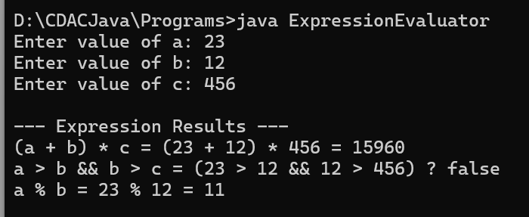

Q19. Employee ID Generator
Create a class Employee:
Requirements:
● Static variable: counter
● Each employee gets auto-incremented ID
● Use constructor to assign ID
● Display employee details
class Employee
{
// Instance variables
int empId;
String name;
// Static counter shared by all objects
static int counter = 1000; // starting ID
// Constructor assigns auto-incremented ID
Employee(String name)
{
this.name = name;
counter++; // increment counter
this.empId = counter; // assign ID
}
// Method to display employee details
void displayDetails()
{
System.out.println("Employee ID: " + empId + ", Name: " + name);
}
}
public class EmployeeIDGenerator
{
public static void main(String[] args)
{
// Create multiple employees
Employee e1 = new Employee("Ramesh");
Employee e2 = new Employee("Sita");
Employee e3 = new Employee("Amit");
// Display details
e1.displayDetails();
e2.displayDetails();
e3.displayDetails();
}
}
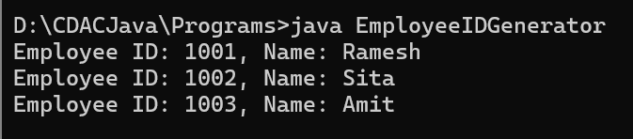

Q20. Library System Create two classes:
Class 1: Book
● bookId, bookName
Class 2: Library
● Method to display books
Requirements:
● Create multiple books
● Pass objects to library
● Display all books
class Book //class 1
{
int bookId;
String bookName;

Book(int bookId, String bookName)
{
this.bookId = bookId;
this.bookName = bookName;
}
void display()
{
System.out.println("Book ID: " + bookId + ", Book Name: " + bookName);
}
}

class Library //class 2
{
void display(Book[] books)
{
System.out.println("\n-----Library Books-----");
for (Book b : books)
{
b.display();
}
}
}
public class LibrarySystem
{
public static void main(String args[])
{
Book b1 = new Book(101, "Java Programming");
Book b2 = new Book(102, "Data Structures");
Book b3 = new Book(103, "Database Management");
b1.display();
b2.display();
b3.display();
}
}
